NAME : SHYAM SUNDAR K
REG NO : 241801268
DEPT : AI&DS

- Create a query to display the last name and salary of employees earning more than 12000.
sol
select LAST_NAME,SALARY
from employe
where SALARY>12000;

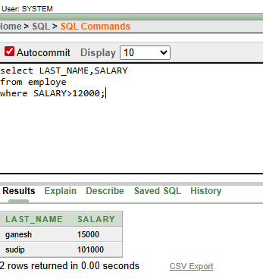

2.Create a query to display the employee last name and department number for employee number 176
select LAST_NAME,DEPARTMENT_NO
from employe
where JOB_ID=176;
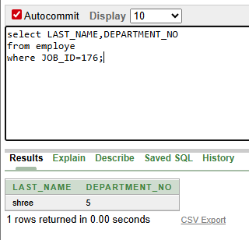

3.Create a query to display the last name and salary of employees whose salary is not in the range of 5000 and 12000. (hints: not between )
select LAST_NAME,SALARY
from employe
where SALARY not between 5000 and 12000;
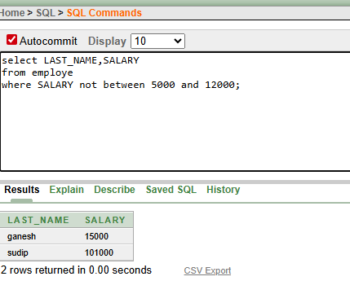

4.Display the employee last name, job ID, and start date of employees hired between February 20,1998 and May 1,1998.order the query in ascending order by start date.(hints: between)
SELECT LAST_NAME,JOB_ID,START_DATE
FROM employe
WHERE START_DATE BETWEEN '20-FEB-1998' AND '01-MAY-1998'
ORDER BY START_DATE ASC;
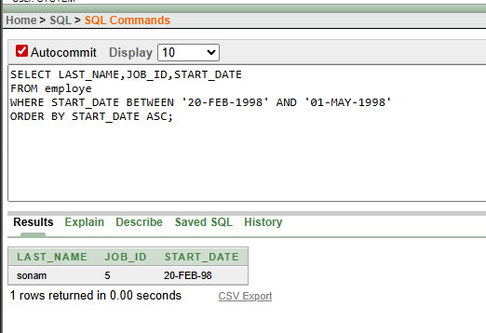

5. Display the last name and department number of all employees in departments 20 and 50 in
alphabetical order by name.(hints: in, orderby)
sol
SELECT LAST_NAME,DEPARTMENT_NO
FROM employe
WHERE DEPARTMENT_NO between 2 and 5
ORDER BY DEPARTMENT_NO ASC;
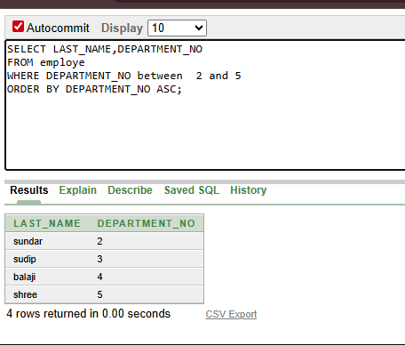

6.Display the last name and salary of all employees who earn between 5000 and 12000 and are in departments 20 and 50 in alphabetical order by name. Label the columns EMPLOYEE, MONTHLY SALARY respectively.(hints: between, in)
SELECT LAST_NAME AS EMPLOYEE,
SALARY AS "MONTHLY SALARY"
FROM employe
WHERE SALARY BETWEEN 5000 AND 12000
AND DEPARTMENT_NO IN (2, 5)
ORDER BY LAST_NAME ASC;
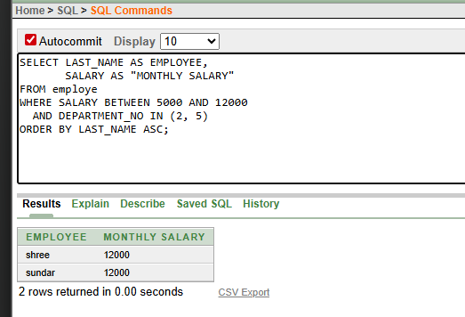

7. Display the last name and hire date of every employee who was hired in 1994.(hints: like)
SELECT LAST_NAME,START_DATE
FROM employe
WHERE to_char(START_DATE,'yyyy')=2025
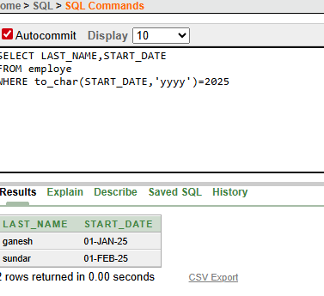

8.Display the last name and job title of all employees who do not have a manager.(hints: is
null)
sol
SELECT LAST_NAME, JOB_ID
FROM employe
WHERE MANAGER_ID IS NULL;
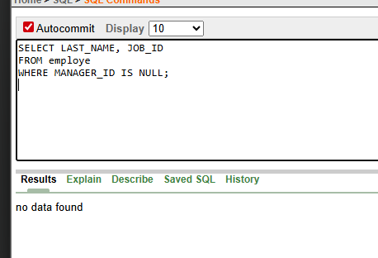

9.Display the last name, salary, and commission for all employees who earn commissions.
Sort data in descending order of salary and commissions.(hints: is not nul,orderby)
Sol
SELECT LAST_NAME,SALARY, commission
FROM employe
WHERE commission IS NOT NULL
ORDER BY SALARY DESC, commission DESC;
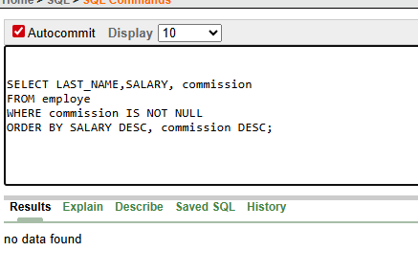

10 .Display the last name of all employees where the third letter of the name is a.(hints:like)
Sol
SELECT LAST_NAME
FROM employe
WHERE LAST_NAME LIKE '_____i%';
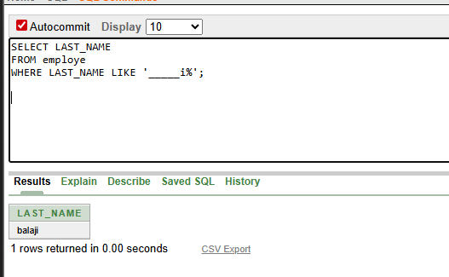

11.Display the last name of all employees who have an a and an e in their last name.(hints:like)
SELECT LAST_NAME
FROM employe
WHERE LAST_NAME LIKE '%i%' and
LAST_NAME LIKE '%e%';

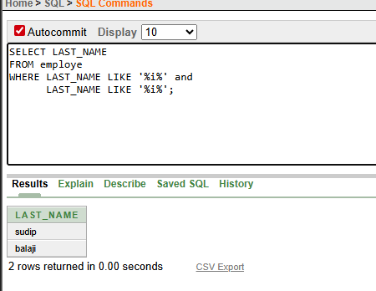

12.Display the last name and job and salary for all employees whose job is sales representative or stock clerk and whose salary is not equal to 2500 ,3500 or 7000.(hints:in,not in)
SELECT LAST_NAME,JOB_ID,SALARY
FROM employe
WHERE JOB_ID IN (176,4)
AND SALARY NOT IN (2500, 3500, 7000);
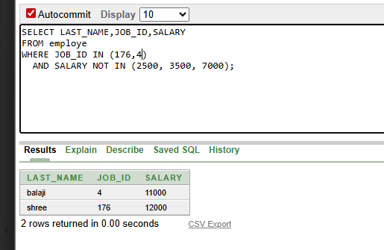

13.Display the last name, salary, and commission for all employees whose commission amount is 20%.(hints:use predicate logic)
SELECT LAST_NAME, SALARY, commission
FROM employe
WHERE commission = 0.2;
